Project PicMe – Design Phase

Justin Storms, Andrian Stepanyuk, Wyatt Stohr

GitHub Repository  
GitHub Link:  
<https://github.com/stormsju/CS380-Final-Project---TeamNamePending.git>  
All team members added. IDE chosen for use: Intellij  
  
Features/Functionality  
Specifics of PicMe include:

* Login and Password management
  + Cryptography-focused due to the sensitive nature of the information held.
  + Non-local storage of credentials so logins can occur anywhere the app is installed.
* Database Management
  + Upload capabilities for storing data in a centralized, local network.
  + Framework to include cloud-based database management (pending success in localized database development).
  + Back-end interface to troubleshoot and interact with the database directly without the requirement for the user to know SQL.
    - Allow for removal of data by administrators.
    - Set backups to prevent failure points.
    - Will not allow administrators to change the structure of the data in the database, that is reserved for development. Documentation system will be provided alongside these privileges.
* User feed and interface
  + User will be able to upload and manage their photos and posts, while being able to link to friends and associates.
    - User feed will pull in the posts of connections made based on a review system.
  + Securities to allow user to approve or deny requests to connect.
  + Securities to prevent unwanted or illegal interactions (profile restrictions, age-related, etc.)
  + Profile To allow the user to express themselves with as much or as little information as they wish (however, this may impact their visibility due to security features).

Database Schema

Example Data Tables from Database

UML Diagram  
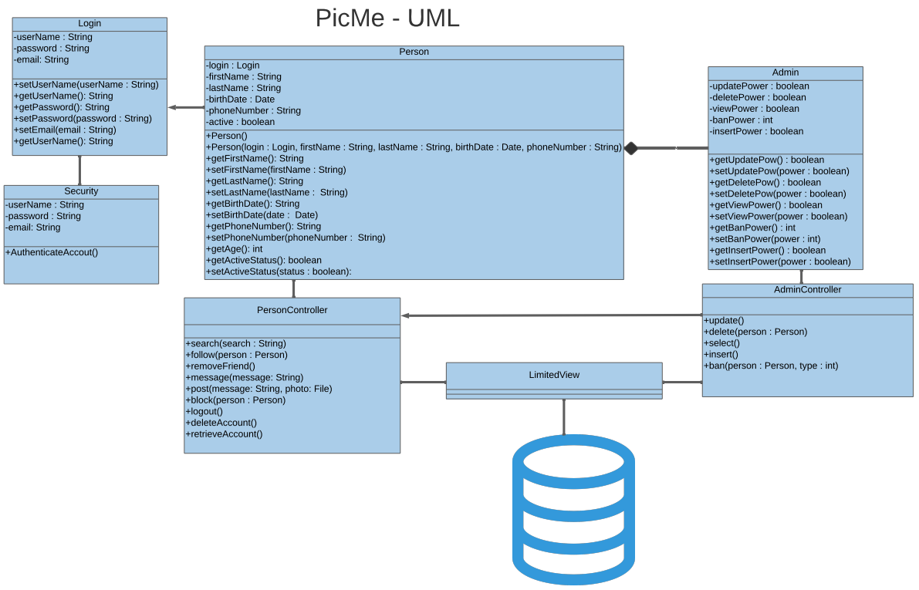

Use Case Diagram

Application Windows

End-User (Public Consumer) UI Example  
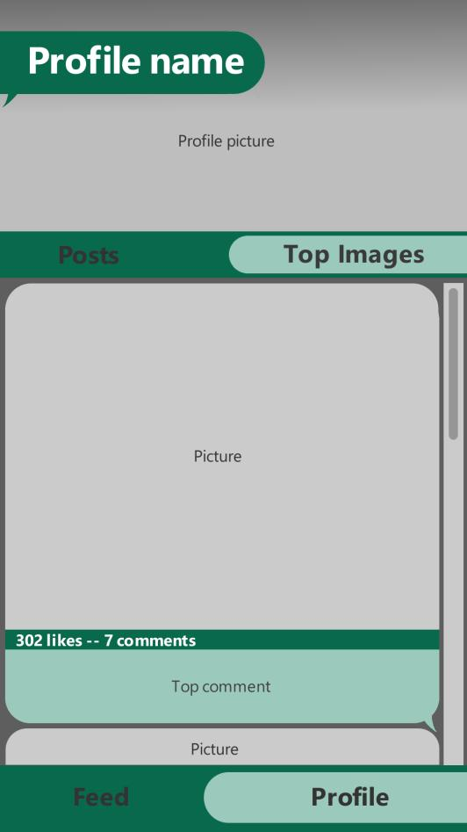

End-User (DB Admin) Login and UI Examples  
